Lab 5 – Tools for studying movements and distribution at sea

This session aims to familiarise you with handling data on marine top predator distribution that have been collected using telemetry devices, animal borne loggers and remote recorders. To plot species tracks, calculate distances with GPS data, plot a density map, and to conduct some basics stats in R. Please hand your answers in, single spaced, 12pt font, times new roman.

Data collection techniques covered include:

Animal-mounted devices

- Satellite transmitters
- GPS Data Loggers
- GPS-GSM Mobile Phone Tag
- Geolocation Loggers

Seabed devices

- T-POD (Echolocation detectors)

Analyses tools covered include:

A shapefile Continents is provided to allow you to explore datasets from both the North and South Atlantic. Remember shapefiles are spatial databases that have five files for each shapefile. They have a projection, attribute table (basically an excel database), and the polygon file.

- Google Earth – for visualising animal tracks and relating to geographical features
- R we are going to use a variety of libraries to map, plot, and analyse data

Case Studies

The case studies on the following pages are numbered 1 to 5. Work through them in sequence with no. 1 following on from no. 5.

1 Satellite Transmitter

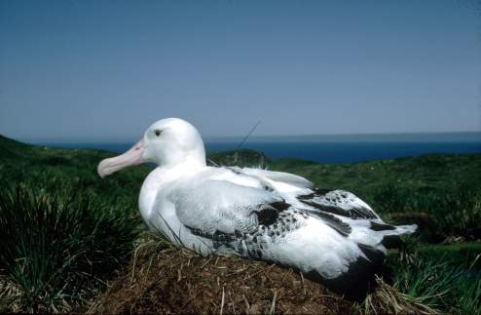

Data from a Wandering Albatross Diomedea exulans courtesy of Richard Phillips, British Antarctic Survey.

Microwave transmitter (see: http://www.microwavetelemetry.com/bird/ )

File name = Albatross_PTT_LD.csv

Questions to explore:

- How frequently are locations obtained through this ARGOS system at this latitude?

- How far did this bird travel from its breeding colony during this 2 week deployment?

- What is the mean, max., average distance travelled per data point (every hour)

2 Geolocation

Data from a male Fulmar Fulmarus glacialis (ID# 1823 Nest 166) from Aberdeen University’s study colony on Eynhallow, in Orkney.

British Antarctic Mk14 GLS logger.

File name = Fulmar_GLS.txt

(see: http://www.antarctica.ac.uk/bas_research/instruments/instrument7.php)

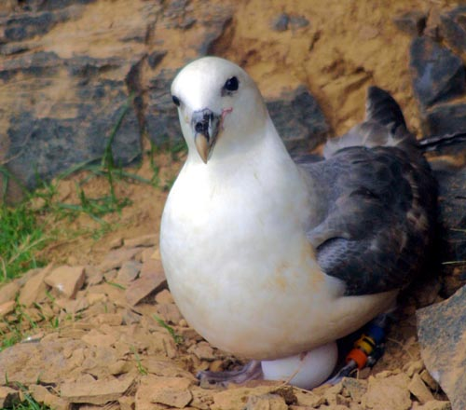

This logger was deployed in July 2007 and recovered in July 2008. However, when using these devices, locations obtained from up to 3 weeks around the 23rd Sept and 21st March equinoxes can be unreliable. This data set has therefore been restricted to the period 15 Oct 2007 to 29 Feb 2008 to allow you to explore the bird’s wintering distribution.

Questions to explore:
- Plot the data on a map, include lat, long axis, legend

- What is the maximum, min., average distance from the breeding colony that this bird travelled?

- Use a kernel density analysis to define the area in the NW Atlantic in which this bird was foraging. Where are the areas that this bird is found in the most?

- Can you find out anything about the biological characteristics of this area at this time of year, and hypothesise why the bird might be so fond of it? (use google searchers and remember this bird eats things on or very close to the surface )

- Tell me about Fulmar life history, ie what do they eat, how do they eat, where do they reproduce

3 GPS Logger

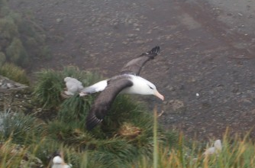

Data from a female Black-browed Albatross Thalassarche melanophrys courtesy of Ewan Wakefield, British Antarctic Survey.

Low resolution data file name: Albatross_GPS_lowres.txt
High resolution data file name: Albatross_GPS_highres.txt

This bird was fitted with two GPS loggers.

- a 27 g logger recording at 1 location/15 minutes (to give data on a complete foraging trip)
- a 8.1 g logger recording at 1 location/sec, to give finer scale data for just the first 2.5 hours of the trip.

Technosmart GPS Loggers: see http://www.technosmart.eu/

Questions to explore:
- put the low res, and high res points on a map together, make sure I can tell which one is which. Also include a continent map so I have a geographic reference.

- What distance did this bird travel during its 6 day foraging trip (low res only)?

- What was the average speed this bird was flying? Also put in the R code that you used to calculate this

- How many data points are there for the high_res file and the low_res? How would the difference in sampling (low and high res) affect estimate a) distance travelled and b) flight speed?
4 GPS-Mobile Phone Tag

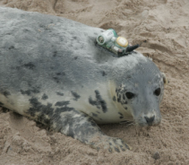

Data from ten Grey Seals Halichoerus grypus caught and tagged on Abertay Sands, courtesy of Bernie McConnell, NERC Sea Mammal Research Unit.

SMRU GSM Phone tag.

See: http://www.smru.st-andrews.ac.uk/Instrumentation/GPSPhoneTag/

Suggested analysis tool: Google Earth.

File name = greyseal.kmz

If you go into Google Earth and then open up file greyseal.kmz then it should fly you to the NE of Scotland where these seals were tracked.

Analysis options are limited in Google Earth, but it offers a number of options for visualising the data. Basic instructions for how to do this are in the files Google Earth Intro.ppt and Google Earth Intro.pdf

Questions to explore:

- Explore the individual variation in the movements of these 10 seals, how are they the same? Difference?

- Which major haul-out areas do these seals appear to use?

5 T-PODS (Timed Porpoise Detectors)

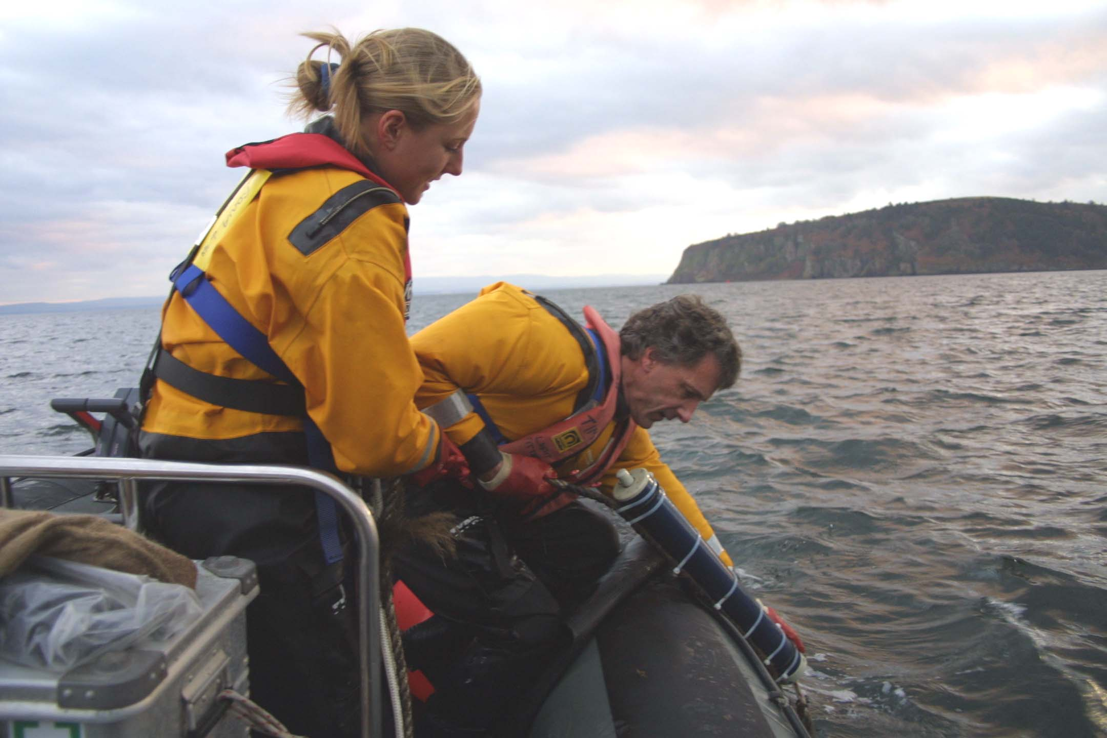

Aberdeen University data from a T-POD that was moored in the mouth of the Cromarty Firth and set to detect echolocation clicks from dolphins and porpoises.

T-PODS are produced by Chelonia Ltd – see: www.chelonia.co.uk

File name = ClickData_LD2.csv

You can also view the file Sutors2006.txt in Excel. This file has been produced from TPOD.exe, and gives the number of dolphin and porpoise click trains that were detected in each hour of the T-POD deployment.

Question:
- What is the mean clicks for dolphins? Porpoises?
- Is this difference significant? Report your pvalue and tell me what that means
- Provide a plot of the relationship between day and number of clicks. Plot should have point, and two lines (one for dolphins and porpoises). Points should be colour according to species
- What is the mean number of clicks during the day and night for dolphins?
- Are the means significantly different? What is the pvalue
- What is the mean number of clicks during the day and night for porpoises?
- Are the means significantly different? What is the pvalue (porpoises)?

